1. Agenda:
   1. Convert in-memory authentication into DB authentication.
2. 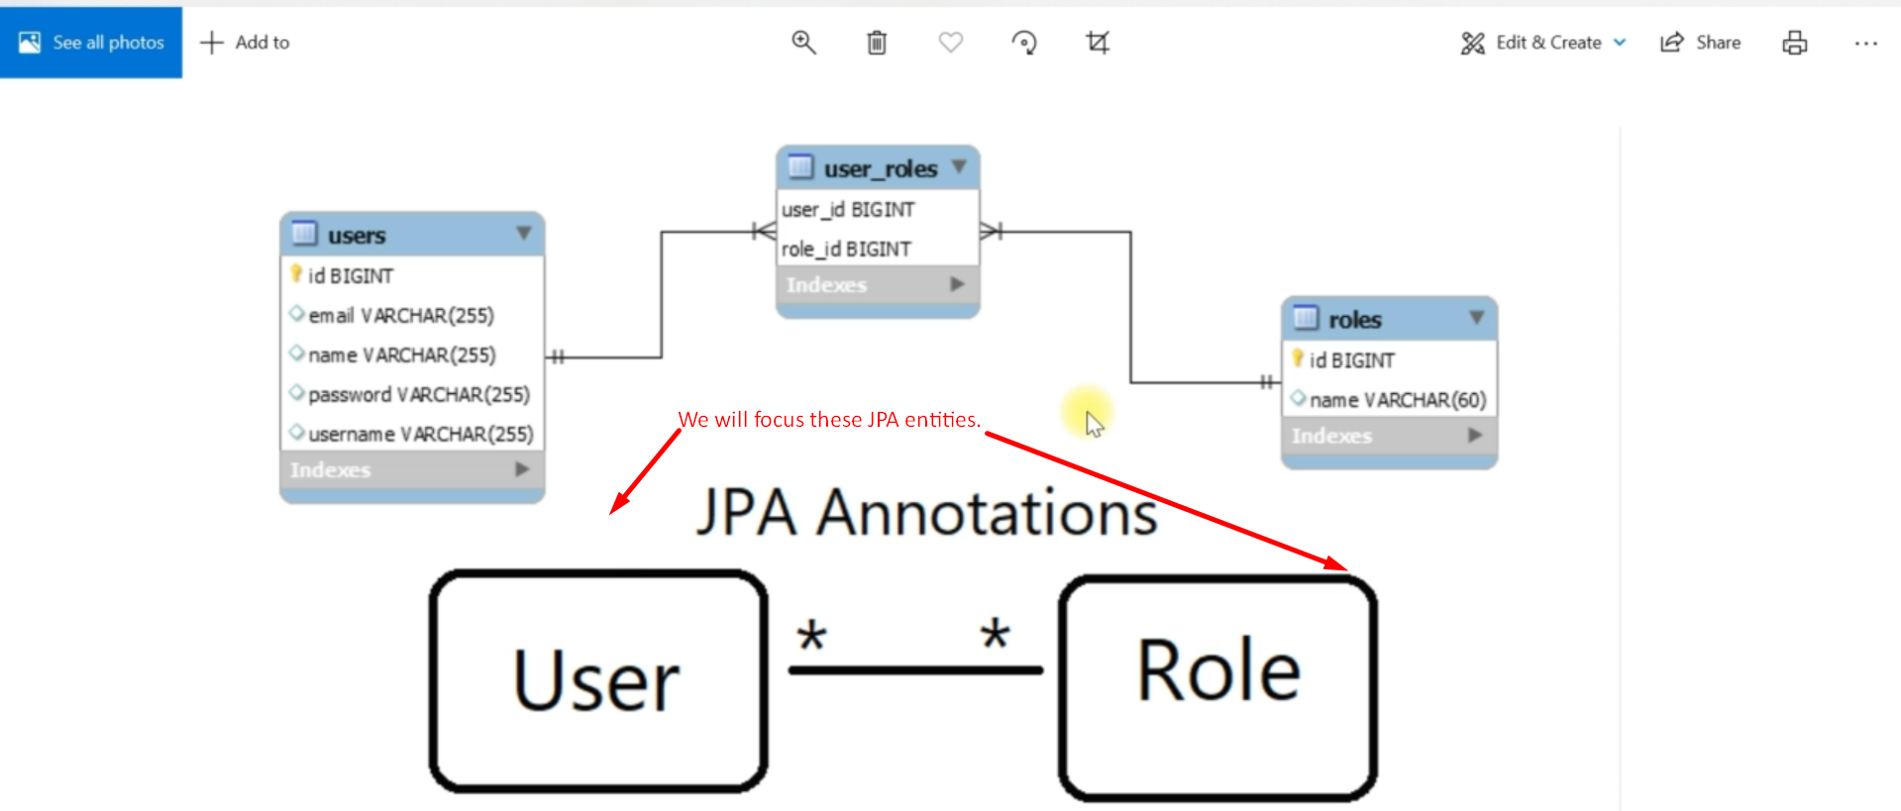
3. 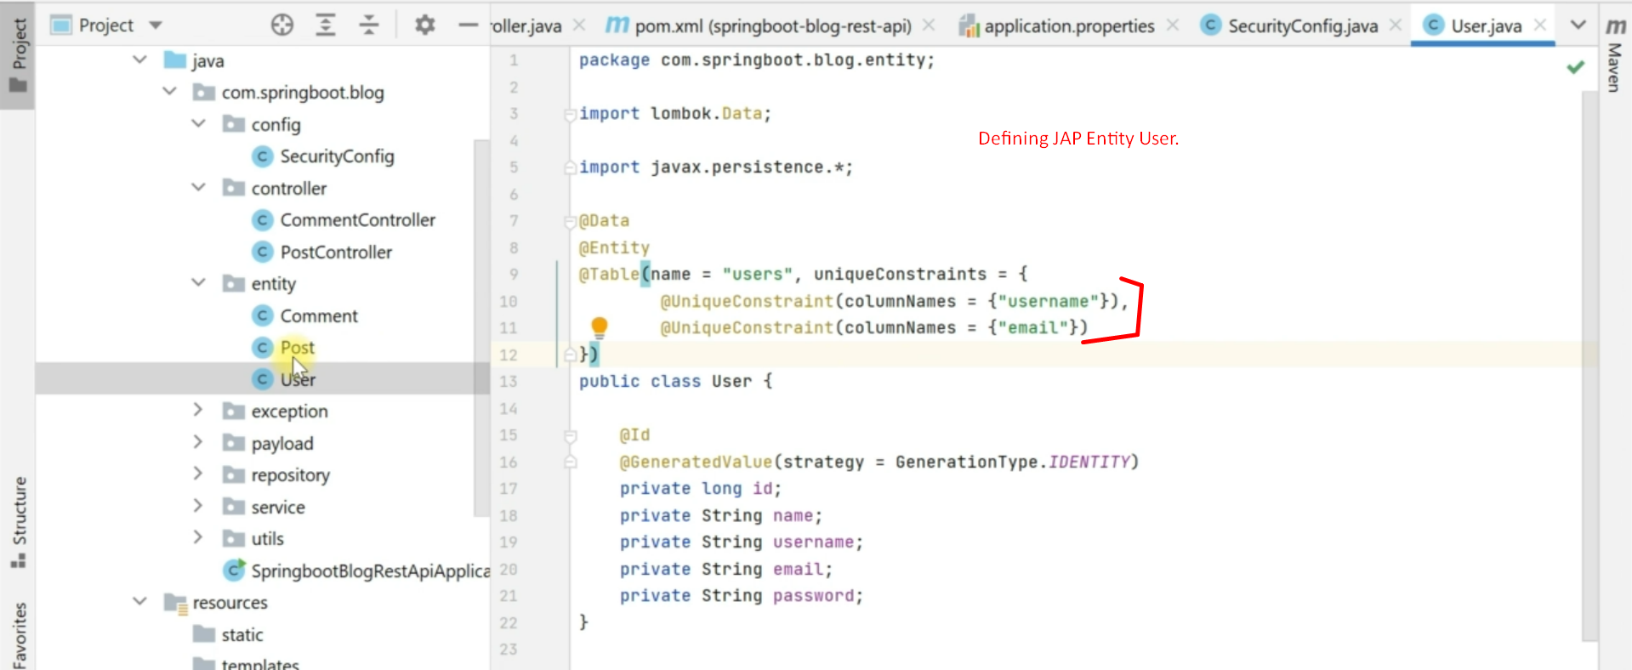
4. 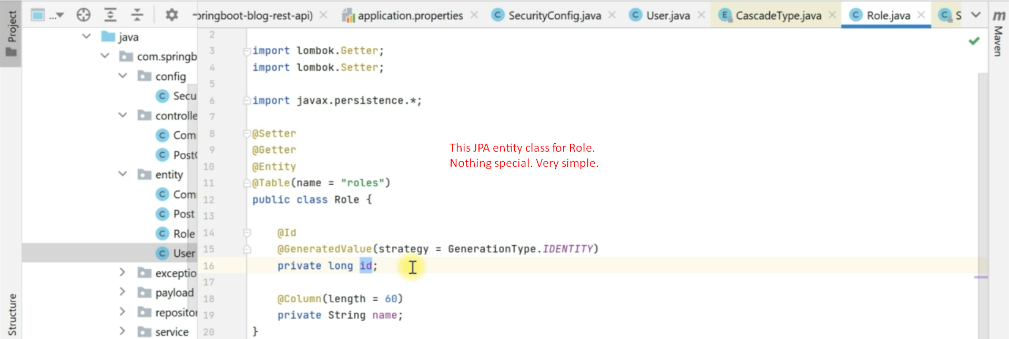
5. 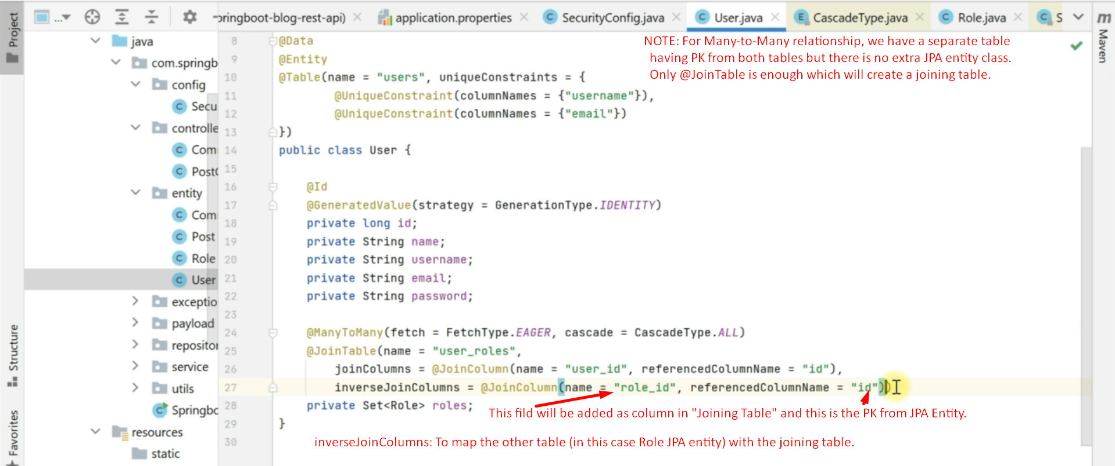
6. After running the app, we can see the corresponding tables are created.  
   